**Editorial comments**

1. Comments, queries and suggestions for changes are highlighted in yellow in the text.
2. Some references in the text are not in the list and vice versa. Please rectify.
3. None of the references in the list after the Annex are in the text. Either insert them or delete.

**CHAPTER 1**

**WHY AN INCLUSIVE AGRICULTURAL TRANSFORMATION IS AFRICA’S WAY FORWARD**

KEY MESSAGES

1. Africa has undergone a pattern of growth based on services over the past decade, increasing rather than reducing the need for agricultural transformation. This pattern has just changed the nature of the transformation that is required.
2. Africa’s food systems are undergoing a period of dynamic change which is creating many new growth opportunities, but whose full exploitation requires an agricultural transformation.
3. The agricultural transformation that Africa needs today has to be much more focused on a market driven, business agenda that encompasses the entire food system, not just agricultural production.
4. From among the alternative pathways there are for achieving this transformation, this Africa Agriculture Status Report (AASR) promotes that which recognizes the dominance of small farms and small and medium-sized enterprises (SMEs) in Africa’s food systems today, and recommends an “inclusive” transformation based on promoting their growth.
5. Because of the diversity of Africa’s small farms, they need different kinds of. The ability to segment small farms and identify them on the ground for targeting purposes has become important and new lines of research using recently available farm household panel data sets, and spatially referenced data and geographic information system (GIS) techniques can facilitate targeting in small farm assistance programs and projects.
6. Although the private sector can do many things on its own, achieving an inclusive transformation of the food system does require proactive public sector policies and investments.
7. Finding ways to commit to this transformation agenda is a real challenge, as is dealing with the weak capability of public institutions which serve the agriculture sector.
8. Given the practical realties of weak public institutions and sparse infrastructure in many countries, a first mover strategy that prioritizes specific segments of the agri-food system for early development can make a lot of sense. First mover approaches provide platforms that enable relevant public and private sector players to come together to better serve groups of smallholder farms, while enabling public and private investments in infrastructure and supporting services to achieve critical levels.

***Introduction***

This chapter provides an overview to the 2017 Africa Agriculture Status Report (AASR 2017). It begins by reviewing the case for prioritizing agriculture, arguing that Africa’s recent pattern of growth based on “urbanization without industrialization” has increased rather than reduced the need for an agricultural transformation. It argues that many things are now coming together in ways that give Africa the need, the opportunity, the means, and the ambition to transform its agriculture sector. The question now is not whether Africa needs an agricultural transformation, but rather what kind of transformation it needs and how to achieve it.

African economies experienced unprecedented rates of economic growth over 2005–2015, as well as rapid urbanization. However, unlike Asia, this has not led to a shift of workers from agriculture to urban-based industries, especially export manufacturing. Nearly all the non-agricultural growth has been in the services sector, and while this has created many additional jobs, they are mostly low productivity jobs. This pattern of urbanization without industrialization offers limited scope for more rapid and sustained growth in national per capita incomes, highlighting the need for more proactive efforts by governments to promote growth in higher productivity segments of the economy, and shifting more workers into those activities. Renewed efforts to modernize the agriculture sector, or at least large parts within it, could make a valuable contribution to national economic growth in many countries, and to poverty reduction.

Along with more rapid economic growth, Africa’s food systems have also changed. Demand for food is growing strongly, and national diets are shifting away from food staples like grains towards more horticultural and livestock products, and processed and pre-cooked foods. Food systems are becoming more urban based and consumer driven, with a premium on quality and food safety. Imports of many raw and processed foods that could be produced at home are also growing rapidly. Driving these changes are rapid urbanization, rising incomes, globalization, population growth, and a growing share of young people.

This dynamic is creating many new growth opportunities within Africa’s food systems, which could help provide the boost to national economic growth and productive employment that most countries seek. Already a great deal of value addition and employment is being created by small and medium-sized enterprises (SMEs) along value chains in the form of agricultural trade, farm servicing, agroprocessing, urban retailing and food services. Large agribusinesses like seed companies, agroprocessors, and supermarkets are also playing an increasing role in some agricultural value chains. Governments have the opportunity to leverage these dynamics to create even more growth in productive employment and income, and in ways that benefit young people and the poor.

However, the type of agricultural transformation relevant today is very different from the kind of green revolution transformation that Africa aspired to in earlier decades. The new agenda needs to be much more focused on a market driven, business agenda that encompasses the entire food system, not just agricultural production. But Africa is at a crossroads: should it go for a food system transformation led mainly by large commercial farms and large agribusinesses, as in many rich countries? Or should it go for an “inclusive” transformation based on commercial smallholder farms and SMEs along value chains. A large farm, large agribusiness approach would leave millions of small farms and businesses without adequate livelihoods, whereas an inclusive approach could engage more of them in productive employment, create more attractive jobs for young people, help reduce poverty, inequality and food insecurity, and contribute to better nutrition outcomes. But an inclusive approach would also require greater public sector involvement and investment, and hence government commitment to the transformation agenda.

This AASR argues for an inclusive approach to transforming Africa’s agriculture sector and food systems more widely. Chapters in this report describe the ongoing changes in Africa’s food systems, and the opportunities and challenges that an inclusive transformation approach would involve. They explore the rationale for the approach, and the kinds of policy, public investment, and governance issues that would be required.

***Why agriculture is still critical for Africa’s economic transformation***

Economic growth accelerated across much of Africa during 2005–2015 (Figure 1.1). Although outpaced by Asia, the rates of growth achieved were nevertheless unprecedented for many African countries, and led to a period of euphoria among many experts in which African economies seemed finally to be taking off. As should be expected, this growth has been accompanied by structural changes in the composition of national economies (Figure 1.2). Agriculture has shrunk as a share of both national gross domestic product (GDP) and the total labor force. A surprise has been the rapid urbanization of Africa. Already, 37% of the population in is urbanized, and the UN projects that by 2050 the urban population share will reach 56% (UN, 2014). This urbanization is surprising because, unlike the economic transformations of China and some other fast growing Asian economies, workers have not moved into manufacturing. Rather, in much of Africa, industry at large, including manufacturing, has remained flat while workers have moved into a burgeoning and mostly urban-based services sector. The services sector is now the largest sector in Africa, and already accounts for over half of Africa’s total GDP (Figure 1.2; Rodrik, 2016). This pattern of growth has been characterized as “urbanization without industrialization”.

Figure 1.1: Regional trends in GDP per capita (1990–2015)

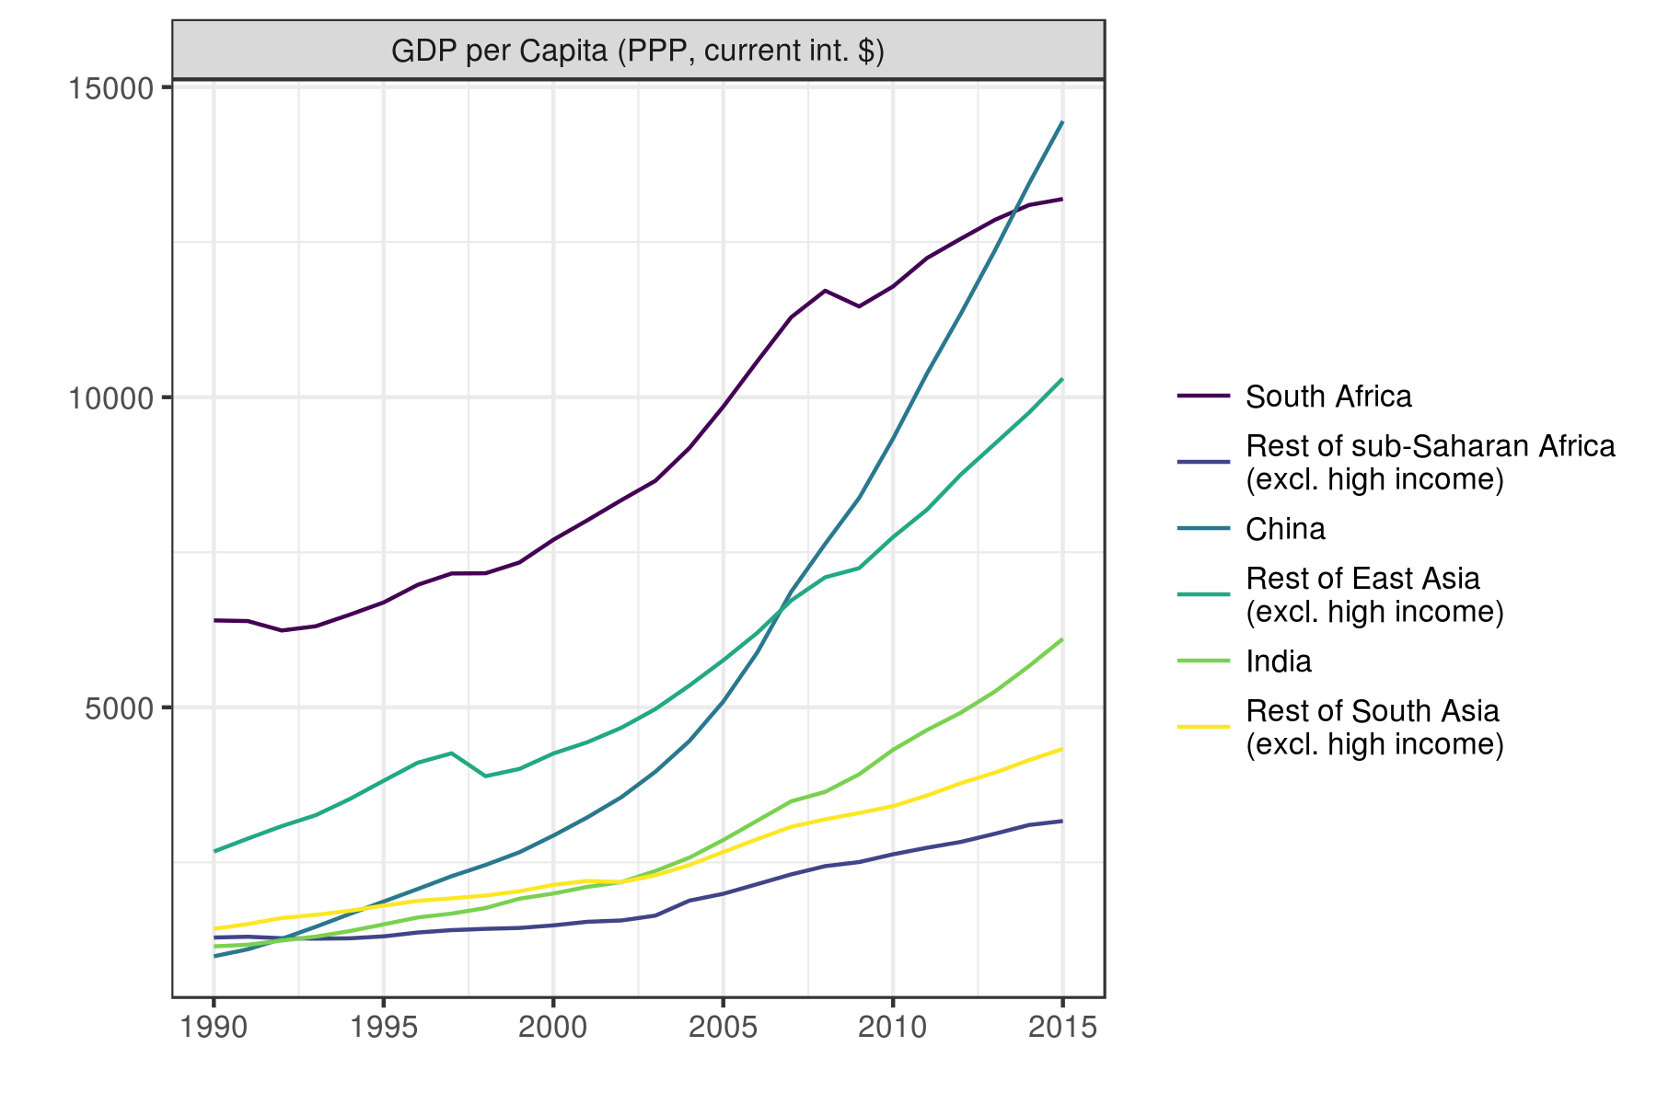

Source: WDI (the raw data are available at [2017-agra-aasr_WDI_ts (corrected).csv](https://github.com/mbacou/2017-agra-aasr/blob/master/out/MB/2017-agra-aasr_WDI_ts%20(corrected).csv))

Figure 1.2: Sector shares in total GDP, sub-Saharan Africa

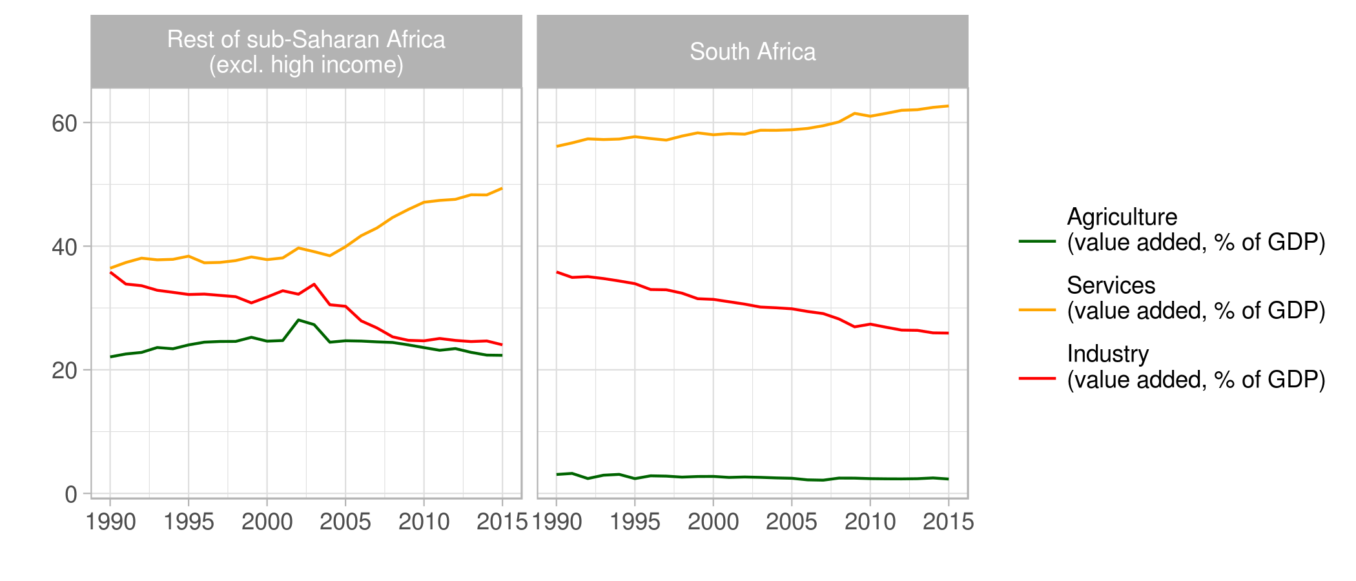

This pattern of economic transformation has some problems. For starters, it turned out that Africa’s growth spurt was driven more by a commodity price boom than any real improvement in its economic fundamentals, and when prices turned so did economic growth rates. Also, the growing dependence on the services sector does not offer a sustainable pathway to rapid economic growth. This is because most services are informal, labor-intensive activities, whose labor productivity is little if any better than traditional agriculture. Unlike manufacturing, which faces an elastic demand for its outputs, either through exports or import substitution, the services that are produced are mainly for the domestic market (i.e., they are non-tradables), so their growth is constrained by growth in national demand. Demand, in turn, depends on growth in national per capita incomes, population sizes, and changing patterns of consumption associated with the movement of people from rural to urban lifestyles. This pattern of transformation can only take Africa so far, and will at best lead to modest rates of national economic growth (Rodrik, 2016; McMillan, Rodrik, & Sepúlveda, 2016).

How can Africa accelerate and sustain its growth rate and become more of a hare than a tortoise? Growth in GDP per capita is highly correlated with growth in labor productivity, and there are two basic sources of potential growth in labor productivity. One is growth of labor productivity within sectors. The other is growth of high labor productivity sectors like manufacturing and the movement of workers to those sectors from lower productivity ones. So far growth in labor productivity in Africa has arisen mainly through increases in “within-sector” labor productivities (Badiane & Makombe, 2015 NOT IN REF LIST; McMillan et al., 2016). While continued productivity growth within sectors is likely, it is generally quite modest, and faster economic growth needs to come from growing the more productive parts of the economy and facilitating the movement of workers to those activities.[1] What are the prospects for that?

Industry

There are reasons to be pessimistic about Africa’s potential to become a major hub of export manufacturing, at least at a time when China and other Asian countries are flooding world markets with low cost manufactured goods. Manufacturing in Africa is also widely constrained by a poor business environment, high transport costs, inadequate and costly port facilities, unreliable power supplies, inadequate access to finance, difficulties in obtaining land, rising labor costs, shortage of skilled workers, etc. (Manufacturing in Africa, 2016). Rather than an exporter, Africa has become an important importer of manufactured goods. For example, China’s exports of manufactured goods to Africa increased from US$4.4 billion in 2000 to US$86.7 billion in 2013; an average annual growth rate of 28% (Guillaumont, Jeanneney & Hua, 2015 INDICATE AUTHOR INITIALS IN THE REF LIST).

Niche opportunities undoubtedly exist for some African countries to develop export manufacturing, and those opportunities should of course be pursued. But for most of Africa, more promising short to medium-term prospects lie at home and particularly in the growth of small and medium-sized manufacturing firms which can supply growing domestic and regional markets. One particular promising opportunity lies with food industries, which face a rapidly growing urban market for processed and pre-cooked foods. This sector is still dominated by many small and medium-sized firms, and has the potential to grow many more reasonably productive jobs. However, agroprocessing firms face many of the same constraints as manufacturing firms in general, as well as challenges in obtaining reliable supplies of raw materials of the right qualities from farmers (World Bank, 2013). Growth will depend on the successful modernization of many agricultural value chains.

Services

The rapid growth in the services sector has been led by growth in trade and personal services, both of which are dominated by small informal enterprises, and which have grown with per capita incomes and rapid urbanization. For example, trade services have grown with a greater need to move more agricultural commodities from rural to urban areas where more consumers now live. Not all the growth in services has arisen in the cities, and much has occurred in small and medium-sized towns where it has created new off-farm income earning opportunities for farm households in surrounding areas.

The difficulty with the informal services sector is that it has relatively low labor productivity, in some cases no better than traditional agriculture. Although opportunities may exist for developing pockets of modern services that have higher labor productivity, it is unlikely that they can achieve the scale needed to substitute for the development of modern manufacturing and agriculture if Africa is to grow faster.

Agriculture

This brings us to agriculture, which still has considerable potential for growth in Africa. Here are three good reasons to be optimistic about agriculture’s potential:

* Africa still has the resource base that if more intensively farmed could easily produce another 100 million tons of grain equivalents each year, equivalent to adding another US corn belt to the global supply and turning Africa into a net agricultural exporter. This potential is evidenced by the low yields Africa currently achieves compared with those of similar agro-ecological zones (FAO & World Bank, 2009), experimental trials, and best farmer practices (Jirström, Andersson, & Djurfeldt, 2011). There is also considerable untapped irrigation potential[2] and remaining uncultivated land that could be brought into production.[3]
* Demand for food is growing fast. Most African countries are still growing despite the slowdown induced by the decline in commodity prices in 2016, and the medium-term outlook is good for continued growth in international, regional and domestic markets. Africa’s demand for food is projected to more than double by 2050 (Chapter 2), driven by population growth, rising incomes, rapid urbanization, changes in national diets towards greater consumption of higher value fresh and processed foods, and more open intra-regional trade policies, all of which are helping create new opportunities for Africa’s farmers.
* Agriculture is also the best sector for addressing much of the remaining poverty in Africa. Since most farmers are smallholders, many of whom are poor, and increases in agricultural output help keep food prices low, small farm-led agricultural development typically has a big impact on poverty. Thirtle, Lin and Piesse (2002) NOT IN REF LIST estimate that a 1% increase in crop productivity reduces the number of poor people by 0.72 % in Africa and by 0.48% in Asia. Studies that compare growth–poverty elasticities across sectors typically find much higher elasticities for agriculture than for non-agriculture (Christiaensen & Demery, 2007; World Bank, 2007).

Yet despite the promise, Africa has not done well in modernizing its agriculture sector. Many attempts were made to bring the green revolution to Africa in the 1960s and 1970s, some of which were successful in raising productivity (e.g. the maize revolution in Eastern and Southern Africa (Smale & Jayne, 2010)). But they were typically based on top-down, heavily subsidized and state-led approaches that proved costly and financially unsustainable, and had to be pared back as part of the structural adjustment programs (SAPs) beginning in the 1980s.

Although Africa’s agricultural growth rate improved after 2005, averaging about 7% per annum, this was driven more by a commodity price boom and expansion of the cropped area rather than by improvements in the underlying fundamentals.[4] Africa’s cereal yields started to grow after 2000,[5] but still remain low compared to other countries, and the gaps are widening (Figure 1.3). Moreover, the gap in land and labor productivity between Africa and Asia also widened rather than closed over 2000–2014 (Figure 1.4). Within Africa, labor and land productivity improved the least in Southern Africa (excluding the Republic of South Africa), and improved the most in Eastern and Western Africa (Figure 1.5). Far from exploiting its potential of becoming a major breadbasket region, Africa continues to become more dependent on food imports. The aggregate annual food import bill is currently about US$35 billion, and is estimated to rise to US$110 billion by 2025 (Adesina, 2017).

Figure 1.3: Trends in cereal yields in Africa and Asia

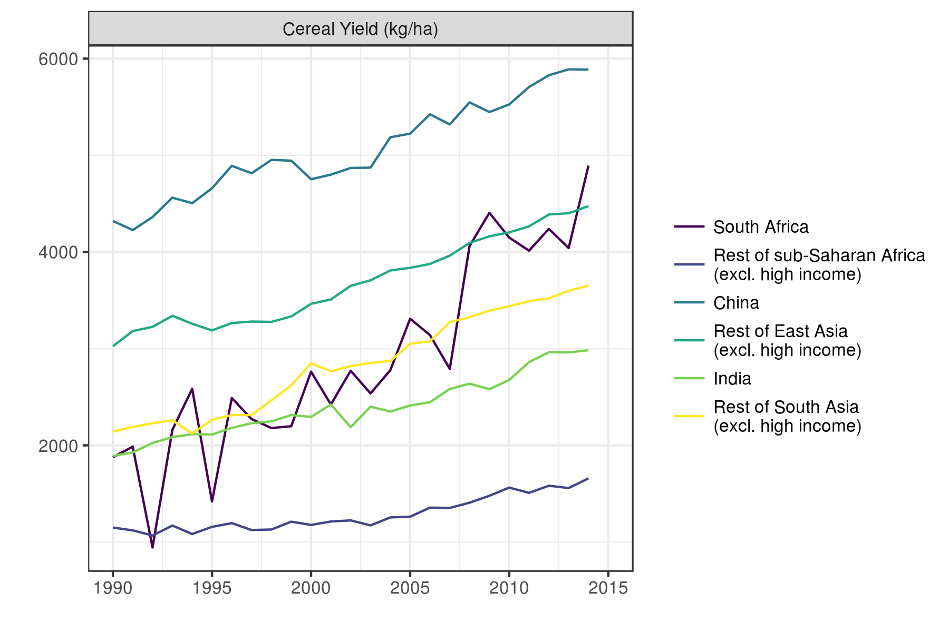

Source: WDI

Figure 1.4: Regional trends in land and labor productivity, Asia and sub-Saharan Africa (2000–2014)

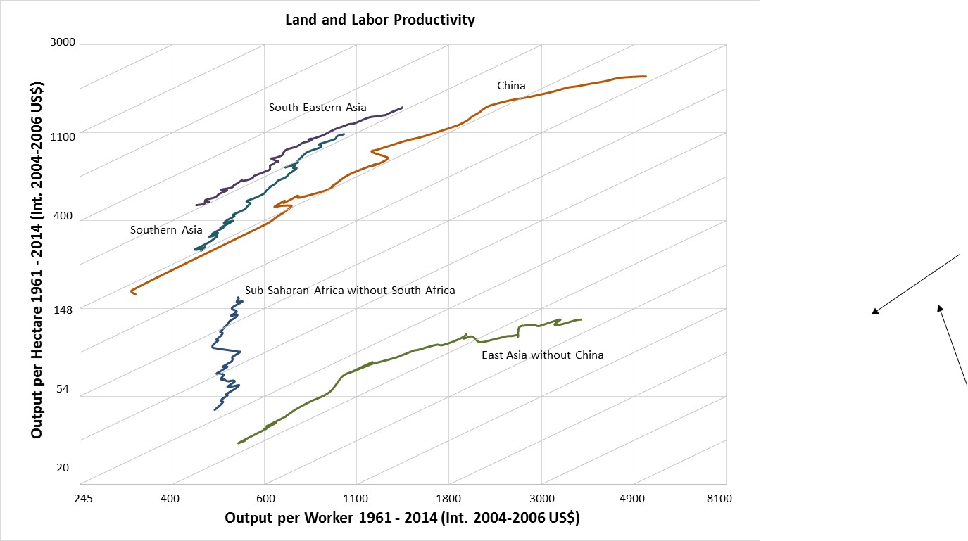

Source: Calculations by Ulrike Wood-Sichra using FAOSTAT, [http://www.fao.org/faostat/en/#home](http://www.fao.org/faostat/en/" \l "home), accessed June and July 2017 (for area harvested, permanent pastures and value of production) and <https://www.ers.usda.gov/data-products/international-agricultural-productivity/> and then values for individual countries (for agricultural labor); The latter WHICH? is maintained by Keith Fuglie (ERS/USDA)

Figure 1.5: Regional trends in land and labor productivity, within sub-Saharan Africa (2000–2014)

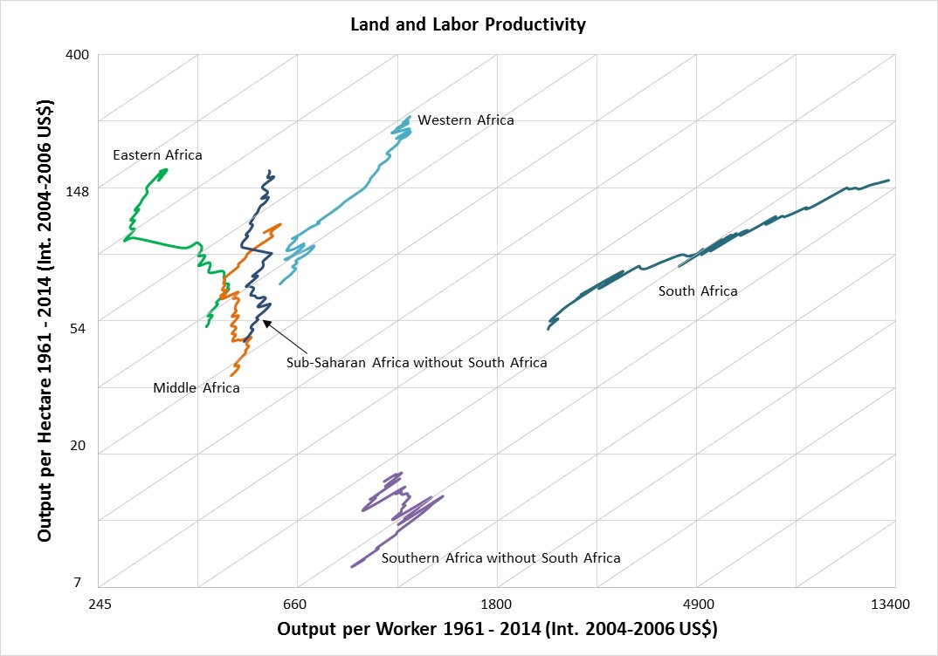

Source: Calculations by Ulrike Wood-Sichra using FAOSTAT, [http://www.fao.org/faostat/en/#home](http://www.fao.org/faostat/en/" \l "home), accessed June and July 2017 (for area harvested, permanent pastures and value of production) and <https://www.ers.usda.gov/data-products/international-agricultural-productivity/> and then values for individual countries (for agricultural labor); The latter WHICH? is maintained by Keith Fuglie (ERS/USDA)

So why has Africa not done better in modernizing its agriculture sector and raising the productivity of its agricultural workers? A green revolution was always going to be a bigger challenge in Africa than in Asia given the continent’s diverse, rainfed farming systems, limited irrigation, and sparse rural infrastructure. Africa needed a “rainbow” revolution to address its diverse array of crops, farming systems and growing environments (InterAcademy Council, 2004). In contrast, Asia was able to enjoy a green revolution based on increasing the yields of just two crops—rice and wheat, grown on vast areas of irrigated land where the same technologies were widely applicable.

Added to these biophysical challenges has been a lack of government commitment to agriculture. Whereas Asian countries were determined to be largely self-sufficient in food staples at a time of world shortages, and spent on average about 15% of their total budgets on agriculture during 1970s and 1980s (Hazell, 2010), African governments never achieved anything like the levels of investment needed, rarely exceeding 5% of their total budgets (Fan, Bingxin, & Saurkar., 2008). Worse, most African governments and donors slashed their investments in agriculture and the institutions that support the sector during the SAP era, leaving a legacy of neglect that is still felt today.

Another problem was that before the SAPs, most African countries pursued macro and trade policies that discriminated against agriculture (Anderson & Masters, 2009). Within agriculture, many African countries also followed the initial Asian Green Revolution model of a top-down, state-led approach that included public provision of agricultural research, extension, and farm inputs, the shoring up farm credit systems, hefty subsidies for key inputs (especially fertilizer), and intervening in markets to ensure farmers received adequate and stable prices each year to make the new technologies profitable. These kinds of interventions can quickly become costly and inefficient, distort markets, and crowd out the private sector, and even where justified, need to be phased out once they have served their initial purposes.[6]

But all this is changing. Most macroeconomic, trade, and agriculture sector policy distortions were successfully pared back as part of the SAPs. Although these reforms were not perfect, they dramatically improved the economic environment for agriculture (Binswanger-Mkhize, & McCalla, 2010). African policy makers have also recognized the renewed importance of agriculture, and through the Comprehensive Africa Agriculture Development Programme (CAADP) process have committed themselves to increasing agricultural investment to 10% of their total budgets, and agricultural growth to 6% per annum. Public sector capabilities are still weak, but growing stronger. In many countries, the institutional environment has also improved and local governments, communities and the private sector have greater opportunities to participate in the agriculture sector. The business climate is also improving, albeit from a low level. And through the Grow Africa Investment Forum (African Union (AU), New Partnership for Africa’s Development (NEPAD), and the World Economic Forum (WEF)), and the New Alliance for Food Security and Nutrition (G7 and AU), international agribusiness has committed to invest in Africa’s food systems.

To conclude, many things are now coming together in ways that give Africa the need, the opportunity, the means, and the ambition to transform its agriculture sector. The question now is not whether Africa needs an agricultural transformation, but rather what kind of transformation it needs.

***What kind of agricultural transformation does Africa need?***

The situation in Africa today is very different from that in Asia at the time of its Green Revolution, and requires a different kind of agricultural transformation. Some key differences:

* Despite occasional shocks like the world food crisis of 2007, the global food balance is much more favorable today than in the immediate Green Revolution era, and international trade in agricultural commodities has soared. This means that African countries have more freedom to meet their food needs through a mix of own production and international trade, and can focus on producing those agricultural commodities which best match their resource endowments and export opportunities.
* African food systems have evolved rapidly in recent years in response to urbanization, rising incomes and changing diets. Although there is considerable country variation, overall there has been a huge increase in the volume of foods that pass through the food system, possibly by a factor of six- to eightfold since 1970 (Reardon et al., 2014). Moreover, some 40–70% of food costs to urban Africans are now incurred in the post-farm-gate segments of the supply chain (processing, wholesale/transport, retail, food stalls, restaurants, etc.) the World Bank estimates that the share of all agribusiness and food-related business in national GDP is typically around 20% in Africa (World Bank, 2013). These changes have been matched by a “quiet revolution” in supply chains, with large numbers of SMEs investing in trucking, wholesale, warehousing, cold storage, first and second stage processing, local fast food, and retail trade (Reardon et al., 2014). There has also been significant investment by larger African and foreign firms. Much of this investment has gone into the midstream of the value chains (World Bank, 2013). Private agrodealers have also expanded into the marketing of modern farm inputs, like seeds, fertilizers, veterinary medicines, and agricultural machines. Tschirley et al. (2015) provide data for six countries in Eastern and Southern Africa, showing that in 2010, the number of jobs in agribusiness was 10% as large as the number of jobs in agriculture, and half as large as all the jobs outside the food system. They also show that labor productivity in agribusiness is five to seven times higher than in agriculture, depending on the type of activity, and project that the agribusiness sector will continue to grow strongly until 2025 and beyond.
* Changing rural demographics are reaching tipping points that require attention. Rural populations continue to grow across much of Africa, and are projected to do so until at least 2050 (AGRA, 2016). With low levels of land productivity, this growth is putting huge pressure on the land base, especially in already densely populated countries. With continuing sub-divisions, many farms are getting too small to support a family, which in the absence of adequate opportunities to diversify into non-farm sources of income, contributes to the overuse of resources and land degradation (World Bank, 2007). An increasing scarcity of arable and grazing lands also contributes to more disputes and conflicts over land and water. Another trend is that the agricultural labor force is growing substantially younger. Yeboah and Jayne (forthcoming NOT IN REF LIST; IS IT IN PRESS?) estimate that about 60% of the agricultural labor force is currently between 15–35 years of age, and the share is growing. Rural youths are looking for better and more productive livelihoods than traditional farming, and are migrating to urban areas even though there are inadequate jobs there. Creating productive and interesting jobs in agriculture and within the agri-food system for young workers needs to be a key plank in the transformation agenda.
* The development agenda has moved on. While food security was the primary goal during the Green Revolution, the agenda of the international community has evolved and development assistance today seeks to address a broad range of economic, environmental and social goals, as encapsulated in the sustainable development goals (SDGs). Improved nutrition and health have emerged as particularly important issues for agriculture and food systems.

Given these changes, it is no longer enough to focus only on transforming agricultural production systems. Today, we need to talk more broadly about the transformation of entire food systems.

In seeking to transform their food systems, African countries have to choose the type of transformation they would like. Just because there is a broad consensus today on the need for an agricultural transformation does not mean there is also a consensus on how that transformation should be achieved. Some scholars and policy makers, for example, argue for a food system transformation based on large-scale commercial farming, and with large agribusinesses like seed companies, agrochemical companies, and supermarkets encouraged to develop and integrate many value chains. This is the kind of food system found in most rich countries today, and even in South Africa. Such food systems can be highly productive, but they are capital intensive, create relatively little employment, and contribute to some unfortunate dietary consequences, like urban obesity. This is an important drawback for Africa given that most of the workforce is currently employed in small-scale farming and along agricultural value chains, and, as we have seen, there is little prospect that they can be quickly absorbed into more productive jobs in the industrial or service sectors.

A contrary view, and the one promoted in this AASR, recognizes the dominance of small farms and SMEs in Africa’s food systems today, and recommends an “inclusive” transformation based on promoting their growth. This approach could create much productive employment and income, reduce poverty, inequality, and food insecurity, lead to better environmental and nutrition outcomes, and help make farming and value chains more resilient to shocks from climate change, and more attractive to the youth.

How plausible is such an inclusive transformation? We explore this question first from the perspective of small farm agriculture, and then examine more broadly the implications for a business strategy to achieve an inclusive transformation of the agri-food system.

***Commercializing small farm agriculture***

Africa has about 51 million farms of which 80% (or 41 million) are smaller than 2 ha in size (Lowder, Skoet, & Raney, 2016), and their numbers are still increasing in most countries (Headey, 2016; Jirström et al., 2011). Africa wide, farms smaller than 2 ha produce about 30% of total agricultural output, while farms 4–20 ha produce another 50% (Herrero et al., 2017). The available evidence shows that many of these farms are efficient low cost producers which obtain higher yields, on average, than many larger sized farms, and are quite able to compete in markets given a fair opportunity (Larson, Otsuka, Matsumoto, & Kilic, 2014). As in Green Revolution Asia, many of these small farms have the potential to contribute to a successful agricultural revolution in Africa, one that is employment intensive and pro-poor.

Coping with the diversity of small farms

Africa’s small farms are diverse and face varying livelihood prospects depending on their own assets and aspirations, as well as their regional and country contexts. There are few “one-size-fits-all” policies for assisting small farms, and hence this diversity cannot be ignored. However, not all small farms can hope to succeed as commercial farms in the future. Those that can need the right kinds of business support, while those who are unlikely to succeed as commercial farmers need different types of assistance. Targeting the rights kinds of assistance requires a typology and a means of recognizing or targeting different types of small farms in programs and projects.

A variety of farm typologies have been offered in the literature to help manage this diversity. Key criteria proposed for segmenting farms include access to markets, household assets, agricultural potential, and non-farm income diversification. Drawing on this work, Hazell and Rahman (2014) proposed classifying smallholders into three groups to target small farm assistance:

* **Commercial smallholder farmers** are successfully linked to value chains and run their farms on a business basis. They may be full or part time farmers.
* **Small farms in transition** have favorable non-farm opportunities and obtain much of their income from non-farm sources. In the absence of significant new opportunities in farming that can give a competitive return to their labor and capital as non-farm opportunities, many transition farmers are likely to leave farming altogether or, if they continue to live on their farms, farm largely for their own consumption.
* **Subsistence-oriented small farms** are marginalized for a variety of reasons that are hard to change, such as ethnic discrimination, sickness, age, or being located in remote areas with limited agricultural potential. Many of the same factors that prevent them being more successful farmers also prevent them from accessing non-farm jobs and becoming transition farmers. Subsistence-oriented farms frequently sell small amounts of produce at harvest to obtain cash income, but are typically net buyers of staple food over the entire year.

Given the focus of this AASR on a business approach to smallholder agriculture, it is proposed to operationalize this typology along the lines portrayed in Figure 1.6. Here **commercial farms** are defined as farm households that sell high shares of their agricultural output. They can be further differentiated into **specialized commercial** **farms** that have low non-farm income shares, and **diversified commercial farms** that have high non-farm income shares. We also identify a group of **pre-commercial small farms**. These are specialized farms with low non-farm income shares that sell part of their agricultural production, but are less successfully linked to markets than specialized commercial farms, selling only medium shares of their farm output. Many pre-commercial farms might, with some appropriate assistance, aspire to become more successful commercial farmers and could make a particularly attractive target group for farm business assistance programs and policies. **Subsistence farms** are defined as those selling low shares of their farm output, and having low shares of non-farm income. **Transition farms** are those that have high non-farm income shares, and sell low to medium shares of their farm output.

Figure 1.6: A typology of small farms

|  |  |  |  |  |
| --- | --- | --- | --- | --- |
|  | | **Importance of farm sales**  (Agricultural sales/total agricultural income) | | |
| Low | Medium | High |
| **Importance of non-farm income**  (Non-farm income/total household income) | Low | Subsistence farms | Pre-commercial farms | Specialized commercial farms |
| High | Transitioning farms | | Diversified commercial farms |

How important are these small farm groups in Africa today? Very little research has been done to answer this question, even for other typologies. One relevant study estimates that only 35 million of the world’s 500 million smallholder farmers (or 7%) participate in tight value chains, meaning that they are generally less poor, operate at least two hectares of land and take a more business-like approach to farming than other smallholders (Christen & Anderson, 2013). An analysis in Annex 1, using household survey data from Ghana, Ethiopia and Tanzania, provides a more encouraging result for Africa. Between 30% and 40% of small farms smaller than 4 ha can be classified as commercial in Ghana and Tanzania, but only about 12% in Ethiopia (Table 1.1). Commercial farms are about equally split between specialized and diversified farms. Pre-commercial farms account for another 15% in Ghana and Tanzania, but 32% in Ethiopia. Transition farmers are the dominant group in all three countries, ranging from 39% to 50%. Subsistence farmers are a relatively small group, less than 10% in Tanzania and Ghana and 17% in Ethiopia.

Table 1.1: Composition of small farms ≤4 ha by type of livelihood strategy, Ghana, Ethiopia and Tanzania

|  |  |  |  |
| --- | --- | --- | --- |
| Non-farm income  as share total income | Share of crop production sold (%) | | |
| Low | Medium | High |
| *Ghana* | | | |
| Low | 8.1 | 14.5 | 22.6 |
| High | 38.9 | | 15.9 |
| *Ethiopia* | | | |
| Low | 17.2 | 32.0 | 6.8 |
| High | 39.4 | | 4.6 |
| *Tanzania* | | | |
| Low | 5.1 | 15.8 | 14.6 |
| High | 49.9 | | 14.6 |

Source: Annex 1

The same data sources can be used to characterize the different types of households in each country (Annex 1). On average, farms that are diversified into non-farm sources of income obtain substantially higher total incomes than subsistence farms or specialized commercial farms. The diversified commercial farmers have the highest incomes, while the subsistence farmers receive the lowest. There is little difference in the household size amongst the five groups, or in the number of adult workers or the age of the head, and commercial farms are not noticeably bigger. However, commercial and transition farms have better educated heads than average, and in Ethiopia and Tanzania, are much more likely to be male headed (Annex 1).

How should assistance vary by type of farm household?

A primary purpose of segmenting small farms is to be able to develop appropriate assistance programs for each group. Assistance needs to be directed at the kinds of transitions that would be desirable for each of the small farm groups. Over time, shown as a move from period t to period t+1 in Table 1.2, it is desired that subsistence farms should become transition, pre-commercial or commercial farms, or exit farming altogether; that many transition farms should become commercial farms or successfully move to the non-farm economy; that commercial small farms should either prosper as such, or transform into larger farms; and that pre-commercial farmers should either succeed in becoming commercial farmers or diversify and become transition farmers. To be avoided are situations where many small farms revert to or remain trapped in subsistence farming, or where transition farms fail to find successful exits to the non-farm economy. In terms of a business approach to small farms, the column shaded in red in Table 1.2 indicates the relevant transitions that are desired.

**Table 1.2: Desired transitions for small farm groups**

|  |  |  |  |  |  |  |
| --- | --- | --- | --- | --- | --- | --- |
| **Period t** |  | **Period t+1** | | | | |
| *Subsistence* | *Transition* | *Pre-Commercial* | *Commercial* | *Exit farming* |
| *Subsistence* | O | X | X | X | X |
| *Transition* | O | X | O | X | X |
| *Pre-commercial* | O | X | O | X |  |
| *Commercial* | O | X | O | X |  |

Notes: X = desired transition; O = undesired transition; red cells designate farm business oriented transitions.

Table 1.3 highlights the kinds of interventions that may be relevant for each of the five small farm groups. Commercial and pre-commercial farmers with viable market prospects need to be supported as a business proposition. They need access to improved technologies and natural resource management (NRM) practices, modern inputs, financial services, markets, and secure access to land and water. Much of this assistance will need to be geared towards high value production, and provided on a commercial and financially sustainable basis. If more subsistence and pre-commercial small farms are to become successful commercial farms, then special help may be needed in acquiring necessary knowledge and skills, and becoming organized to link to modern value chains. This may be especially important for many women and young farmers.

However, this may not be the appropriate strategy for other types of farm households. Transition farmers, for example, may gain more from assistance in developing their technical and entrepreneurial skills and assets to succeed in the non-farm economy, including developing their own non-farm businesses. Such help may be especially important for women and young people. Many transition farmers may simply not be that interested in expanding their commercial farming activities given higher income earning opportunities in the non-farm sector, so unless significant new opportunities exist in farming, assistance targeted at commercial farming may not be productive.

Subsistence farmers are predominantly poor and will often benefit more from some form of social assistance, such as productive safety programs, support for food gardens, and cash transfers and training that facilitates their exit from agriculture. Many subsistence-oriented farmers are too poor or too remote from markets to become successful commercial farmers without long-term subsidies, but assistance that helps them improve the productivity of their farms (e.g. better technologies and NRM practices) can make important contributions to their own food security and perhaps provide some cash income. But subsistence farmers have limited ability to pay for modern inputs or credit, so intermediate technologies that require few purchased inputs may be needed, or inputs will need to be heavily subsidized (e.g. basic amounts of seeds and fertilizer). Subsistence farmers are typically the most exposed and vulnerable to climate risks, and in addition to safety nets, they need help developing resilient farming systems.

**Table 1.3: Types of assistance relevant for different small farm groups**

|  |  |
| --- | --- |
| *Type of small farm* | *Types of assistance* |
| Commercial | **Farming as a business**  Better technologies and NRM practices  Organizing farmers for marketing purposes  Incentivizing large agribusiness to link with small farms  Accessing seeds, fertilizer, finance and insurance on commercial terms  Securing land rights and development of efficient land markets  Encouraging entrepreneurship  Building resilient farming systems |
| Pre-commercial | **Stepping up into commercial farming**  As for commercial farms, but with special attention to developing needed skills and accessing modern value chains.  Some subsidized support may be worthwhile to help launch their businesses. |
| Transition | **Stepping out of farming**  Training and support for non-farm activity, including development of own small businesses  Encouraging entrepreneurship  Empowering women and other vulnerable groups  Securing land rights and development of efficient land markets  Better technologies and NRM practices  Safety nets |
| Subsistence | **Social protection**  Safety nets and transfers  Better but low cost technologies and NRM practices  Perhaps some subsidized inputs for own food crops  Securing land rights  Building resilient farming systems  Empowering women and other vulnerable groups  Support for non-farm diversification |

Targeting assistance

Different forms of assistance vary in how carefully they need to be targeted by type of small farm household. For example, public agricultural research on improved NRM practices or plant and animal disease control may benefit most farmers and needs little targeting, whereas the development of hybrid seeds that must be purchased and fertilized may be of value primarily to commercial farmers. Organizing farmers into groups for marketing purposes will be more worthwhile if most members have commercial capabilities. And agricultural credit needs to be targeted to farmers who have sufficient business activity to be able to repay. Subsidized inputs like fertilizer and seed need to be targeted to specific groups of poor farmers, otherwise substantial leakages can occur. How then can different types of small farms be identified for targeting purposes?

A helpful feature of the typology in Figure 1.6 is that it has an implicit spatial dimension. Production of high value but perishable commodities is more likely in areas with good access to roads and urban areas, and opportunities for non-farm income diversification are also more likely in such areas. Subsistence farmers might be expected to concentrate in less favored areas with poor agricultural potential and poor market access. Since agricultural potential and access to markets and urban centers can be mapped, it is possible to use spatially referenced data on these variables to identify areas on maps where different types of small farms are likely to be concentrated. Annex 1 draws on ongoing research to illustrate this approach for Tanzania. Such maps have already been developed for several African countries and could be a useful aid for targeting future development assistance to small farms.

Within spatial areas, further disaggregation of households is possible using household surveys and local knowledge. The private sector, for example, already uses local knowledge to identify farmers with whom it can do business (e.g., sell seeds or fertilizer), and many non-governmental organizations (NGOs) and social protection agencies are experienced at selecting poor and women farmers for inclusion in their development/protection projects. However, NGOs and the public sector are less experienced in identifying farmers who are best served by a farm business approach.

***Business strategies for an inclusive transformation of the food system***

If more small farms are to successfully transition to commercial farms and compete successfully in modern value chains, then, as noted in Table 1.3, they need access to improved technologies and NRM practices, knowledge, modern inputs (like seeds, fertilizers and machinery), financial services, and markets, and secure access to land and water. Many smallholders will also require help acquiring the necessary knowledge and skills to become successful farm business entrepreneurs, especially women and young farmers. Managing market and climate risk is also a growing challenge for many small farms and, in addition to insurance and access to safety nets, they need to develop resilient farming systems.

If SMEs are to prosper along value chains, then they too may need support. In addition to access to good roads and transport systems, they need an enabling business and regulatory environment, reliable supplies of energy and water, secure rights over land for building, assess to financial services, and often training in relevant technical and managerial skills.

As a list of needs, there is little that is new really here and which has not been part of the agricultural and SME development agenda for some years. But as part of a business agenda for an inclusive transformation of the food system, some things require new emphases and approaches:

* The business agenda is not just about improving cereal yields, valuable though that can be. Most small farms are too small to prosper by growing cereals on a commercial basis, even if they could double their yields. They need to diversify into high value crops and livestock activities that yield much higher returns to land. Fortunately, the market demand for these products is growing rapidly, and a key goal of the business agenda is to help more smallholders overcome the many constraints that prevent them from integrating into more lucrative value chains. This requires a much broader and more flexible agenda for the types of support offered to small farms than was the case with a green revolution agenda. For example, farmers need improved seeds for a whole range of high value crops, not just for major cereals, yet most research and development (R&D) systems are not set up for this task.
* Another new thing is the changed business environment prevalent in today’s food systems, and the need for small farmers to build stronger business links with private sector enterprises. Here SMEs play primary roles since, apart from a relatively small share of small farms that are embedded in contract farming arrangements with large agribusinesses, most small farms depend primarily on SMEs to access modern inputs and financial services, and to market and process their output. An inclusive agricultural transformation therefore calls for assistance to SMEs as an integral part of the development agenda, something that cuts across sectors and hence government ministries and budgets.
* There is also new interest by large international agribusinesses in Africa’s food chains, as exemplified by the Grow Africa Investment Forum and the New Alliance for Food Security and Nutrition. Although an inclusive approach to the transformation calls for an emphasis on SMEs, large agribusiness still has some important functions to perform. For example, SMEs have limited access to new technologies from outside their countries (like hybrid seeds), and they lack the scale and market power to develop and enforce quality standards along value chains, or to develop export markets. Nor can they marshal the kinds of financial services that small farms need. Big agribusinesses, including international corporations, can help fill these gaps. They can also help small farms more directly by: a) sourcing more produce from small farms through contract farming and out-grower schemes—scaling up may require working more with intermediaries like marketing cooperatives or farmer associations; b) developing and then helping small farms comply with quality and safety standards; c) developing supply chains for certified seeds, fertilizer, finance and insurance that serve small farms—this will typically require networking with SMEs along value chains; and d) investing in farm advisory services for small farms and developing market information systems for small farms using the latest information technology and communications technologies.
* Climate change is emerging as a real game changer that requires an adequate policy response. Average crop yields are falling with shorter growing seasons and higher temperatures, and more frequent and severe droughts and pest outbreaks are increasing the risk of seasonal production losses. More extreme weather not only has an impact on the productivity and welfare of farmers, but it also has repercussions along value chains that affect the supply and prices of foods, the viability of many SMEs, and ultimately the welfare of many poor people. Risk is hardly a new feature in African agriculture, but there is need to build more resilience into farm production systems and in the down and upstream segments of value chains.
* Another new thing is the growing recognition that many smallholder farmers are simply not going to succeed as commercial farms in today’s food systems. Some smallholders have opportunities to diversify into more remunerative non-farm activities, and hence may be less interested in commercial farming, while others are constrained from being more successful as farmers by poor access to markets, or because they live in areas with low agricultural potential. Yet others are constrained by insufficient personal assets and capabilities to become successful entrepreneurs in either farming or non-farm activity. A key argument in this report is that agricultural assistance aimed at commercializing more small farms needs to be targeted to those farm household that have viable farm business prospects and capabilities. Alternative types of assistance are needed for the others if resources are not to be wasted, or farm households misled into unsustainable livelihood strategies. The ability to segment small farms and identify them on the ground for targeting purposes has become important and new lines of research using recently available farm household panel data sets, and spatially referenced data and GIS techniques can facilitate targeting in small farm assistance programs and projects.

Although the private sector can do many things on its own, achieving an inclusive transformation of the food system does require some proactive public sector policies. In particular, governments need to create an enabling business environment for agribusiness, build rural infrastructure, invest in agricultural R&D and extension for small farms, protect intellectual property rights, and help establish and enforce grading systems and health and safety standards for many farm products. There may also be need for innovative public sector interventions to help overcome initial market failure problems, such as promoting public–private partnerships to help deliver financial services and insurance to small farms, and organizing small farms into groups for marketing purposes. Some NGOs are very effective at assisting by playing intermediary roles. SMEs also need support as many have trouble accessing credit, and many lack business management skills and need training. These constraints can be overcome through setting up investment funds and training programs to support networks of SMEs. A good example is the type of support provided to small agrodealers by the Alliance for a Green Revolution for Africa (AGRA).

A real challenge is to find ways of convincing governments to actually commit to this agenda, and undertake what many of them have already promised to do (e.g. through CAADP). This is partly a challenge of political leadership, and of rallying and maintaining public support for the agenda, especially in more democratic countries. There is also a problem of institutional capability. Many public institutions are weak, especially those that serve the agriculture sector, and they have limited capability to design, implement, monitor and evaluate government programs and projects, or to work in partnerships with private sector and NGO players. Sometimes it is not just a lack of capabilities that prevents effective partnerships, but public sector skepticism about the roles of other non-government players. The seed sector is a classic example where public institutions have tried to crowd out private breeders and dealers for decades.

Given the practical realties of weak public institutions and sparse infrastructure in many countries, a first mover strategy that prioritizes specific segments of the agri-food system for early development can make a lot of sense. These might be priority commodities or regions, and the aim would be to drive these hard for early successes. Establishing quick success helps build momentum and political support for further agricultural investment, as well as opening up new growth opportunities elsewhere in the sector. Several first mover approaches are being tried in Africa, ranging from a carefully prioritized national agricultural transformation agenda in Ethiopia and Rwanda, to the targeted development of specific value chains, to spatial initiatives like agro-corridors, agro-clusters, agro-industrial parks, and agro-based special economic zones. First mover approaches provide platforms that enable relevant public and private sector players to come together to better serve groups of smallholder farms, while enabling public and private investments in infrastructure and supporting services to achieve critical levels.

OVERVIEW OF REPORT

The following chapters in this AASR delve more deeply into the opportunities and challenges facing Africa’s smallholders as they confront the changing realities of the value chains in which they strive to function. Authors identify public policies and investments that can assist, and relevant roles that the public, private and NGO sectors can play.

**Chapter 2** provides an overview of some important food related changes that have occurred in Africa in recent years. The chapter also provides model-based projections showing that for sub-Saharan Africa, the production of food staples should about double by 2050, and the production of fruits, vegetables and meat should at least triple. Climate change could reduce these projected increases by as much as 5.1% in the case of cereals, and 1.7% for roots and tubers. Much of this increased production will need to come from farms smaller than 20 ha in size, as they currently supply about 75% of Africa’s food. The chapter highlights the growing potential of agroprocessing to benefit small farms and SMEs, but developing these value chains calls for targeted policies and regulatory interventions to promote quality norms and standards and protect property. If smallholders are going to be integrated into modern value chains at scale, then the authors argue they need to be organized into producer organizations that have the technical, commercial and financial resources necessary to position their members as credible business partners. While cooperatives have attempted to play similar intermediary roles in the past, the authors argue that new types of producer organizations and business models will be required, and this will require more fostering by public and private sector players.

**Chapter 3** also highlights the remarkable changes that have taken place in Africa’s food system in recent years, and the challenges that small farms now face if they want to succeed as commercial farming enterprises. The best opportunities for smallholders lie with high value, labor-intensive crops and livestock, as it will be hard for them to compete with large farms and imports in grain markets. To succeed, most smallholders will need to acquire game changing new skills and investments. Governments can help by investing in infrastructure in secondary cities and towns, increasing the reliability of their energy and water supplies, and building more wholesale market spaces. Policy wise governments can help by promoting more open regional trade, and avoiding destabilizing market policies such as poor management of production shortfalls or publicly held stocks. New forms of business-oriented producer organizations are needed to link smallholders with value chains. Although the authors see the potential benefits of evidence-based, business assistance programs for SMEs, they are doubtful this will enhance their ability to work with smallholders in any organized way. Large agribusinesses may be a better channel for seeking organized linkages with smallholder organizations, and the Grow Africa program and the New Alliance for Food Security and Nutrition are both promoting this approach. Some progress has been made in partnering large agribusinesses with governments for organizing clusters of value chain actors for coordination purposes, and in funding NGOs to bear much of the initial cost of building relationships between private investors and small farms. Such public–private partnerships are now used in “development corridors”. Another evolving approach is “impact investment”, in which governments or donors invest in private sector projects on favorable terms as long as they lead to measurable gains in social or environmental goals alongside a financial return.

**Chapter 4** addresses the challenge of strengthening financial systems for smallholders. The authors highlight the different types of financial needs of commercially-oriented verses subsistence or transition smallholders, and argue that while microfinance has helped meet the needs of subsistence farmers, there is a big gap in meeting the business needs of commercial farmers who earn little non-farm income. One reason for the gap is that financial institutions are reluctant to lend to small farms because of the high risk and service costs involved, a lack of usable collateral, and a history of political interventions in agricultural credit markets that work against lenders. Some good news is that contract farming arrangements are enabling some smallholders to gain access to credit, and recent developments in information and communication technology (ICT), the rapid penetration of mobile phones and payment services, value chain financing, and new forms of insurance, are opening up new opportunities for the spread of financial services to a wider range of commercial smallholders and SMEs along value chains. Governments can help by improving financial regulations, developing credit-reporting systems, supporting warehouse receipt systems, and by sharing part of the risk with lenders through credit guarantees and matching funds. Interest rate caps and mandatory lending targets have led to mixed results, and do not necessarily lead to increased lending to the smallholders rather than larger farms. Agricultural insurance has improved in recent years with advances in the design and administration of various types of index insurance, and this is opening up new possibilities for insuring farmers’ loans and the financial institutions that lend to them.

**Chapter 5** addresses appropriate responses to the challenges posed by climate change for Africa’s food systems. Agriculture has always been a risky business in much of Africa, but climate change in worsening the problem. It threatens to reduce average crop and livestock yields, while also increasing the risks of major seasonal losses. These production shocks also have repercussions along value chains, affecting the supply and prices of foods, the viability of many SMEs, and the welfare of many poor people. Commercializing smallholder farms and linking them to modern value chains can help increase their incomes and assets, and hence strengthen their reserves for coping with seasonal losses. But it also exposes them to new financial, production, and marketing risks. There are many things farmers can do to add greater resilience to their livelihoods, such as crop and income diversification, making risk-reducing investments like irrigation, and by adopting climate smart farming practices. Policy makers can assist by investing in R&D on climate smart agriculture, promoting the development of weather-based agricultural insurance, facilitating the more widespread availability of rural credit and other financial services, and maintaining adequate rural safety nets. To build greater resilience into national food systems, governments should also consider policies that can help stabilize national food supplies and prices, such as maintaining an adequate national food reserve for emergencies, freeing up food markets to greater regional and international trade, and buying up surplus food in low price years for school feeding programs.

**Chapter** 6 reviews the policy agenda for achieving an inclusive transformation of Africa’s food systems. In addition to providing the basics—a stable and enabling economic and legal environment, rural infrastructure, agricultural R&D, maintain safety nets and social protection programs for the chronically poor, etc.—governments also need to strengthen public institutions to better perform their roles, and undertake targeted interventions to help commercialize many more smallholders, and promote the development of local SMEs that play strategic roles along agricultural value chains. A key message is that an agricultural transformation of the kind articulated throughout this AASR will require significant government commitment, and a proactive policy agenda. Given the practical realties of weak public institutions and infrastructure, a first mover strategy that prioritizes specific value chains or specific regions for early development can make a lot of sense.

The final chapter pulls together the main findings and recommendations of the report.

**References**

AGRA. (2016). *African Agriculture Status Report 2016: Progress towards agricultural transformation*. Nairobi, Kenya: Alliance for a Green Revolution for Africa (AGRA).

Adesina, A. (2017). <http://www.africanews.com/2017/04/21/why-is-africa-importing-35bn-in-food-annually-afdb-boss-asks//> WHAT KIND OF PUBLICATION IS THIS?

Anderson, K., & Masters, W. (2009). *Distortions to agricultural incentives in Africa*. Washington, DC: The World Bank.

Badiane, O., & Makombe, T. (2014). *Beyond a middle income Africa: Transforming African economies for sustained growth with rising employment and incomes*. *ReSAKSS Annual Trends and Outlook Report 2014*. Washington, DC: International Food Policy Research Institute.

Binswanger-Mkhize, H., & McCalla, A. F. (2010). The changing context and prospects for agricultural and rural development in Africa. In P. Pingali, & R. Evenson (Eds.), *Handbook of agricultural economics* (Volume 4). Amsterdam: Elsevier.

Christen, R., & Anderson, J. 2013. Segmentation of smallholder households: Meeting the range of financial needs in agricultural families (Focus Note 85). CGAP, April. INSERT PUBLISHER NAME AND LOCATION

Christiaensen, L., & Demery, L. (2007). *Down to earth: Agriculture and poverty reduction in Africa*. Washington, DC: The World Bank.

Collier, P., & Dercon, S. (2009). *African agriculture in 50 years: Smallholders in a rapidly changing world*. Paper presented at the Expert Meeting on How to Feed the World in 2050. Food and Agriculture Organization of the United Nations, Rome, June 2009. Retrieved from <ftp://ftp.fao.org/docrep/fao/012/ak983e/ak983e00.pdf> NOT IN TEXT

Conway, G. (2012). *One billion hungry: Can we feed the world?* Ithaca, New York: Cornell University Press.

Deininger, K. (2014). Securing land rights for smallholder farmers. In P. Hazell, & A. Rahman (Eds.), *New directions for smallholder agriculture*. Oxford: Oxford University Press. NOT IN TEXT

Djurfeldt, G., Aryeetey, E., & Isinika, A. (Eds.). (2011). *African smallholders: Food crops, markets and policy*. Wallingford, Oxford: CABI. NOT IN TEXT

Djurfeldt, G., Holmen, H., Jirstrom. M., & Larsson, R. (Eds.). (2005). *The African food crisis: Lessons from the Asian Green Revolution*. Wallingford, Oxford: CABI. NOT IN TEXT

Dorward, A. R., Kydd, J., Poulton, C., & Bezemer, D. (2009). Coordination risk and cost impacts on economic development in poor rural areas. *Journal of Development Studies, 45*(7), 1093–1112.

Dorward, A. R., Kydd, J. G., Morrison, J. A., & Poulton, C. D. (2005). Institutions, markets and economic coordination: linking development policy to theory and praxis. *Development and Change*, *36*(1), 1–25.

Manufacturing in Africa: Still struggling with the basics. (2016, March 16). *The Economist*. Retrieved fromhttp://country.eiu.com/article.aspx?articleid=754034459&Country=South%20Africa&topic=Economy&subtopic=Regional+outlook&subsubtopic=Economic+growth

FAO. (2009). *How to feed the world in 2050* (Forum Background Document, October). Rome, Food and Agriculture Organization of the United Nations (FAO). Retrieved from [www.fao.org/wsfs/forum2050/wsfs- background-documents/hlef-issues-briefs/en/](http://www.fao.org/wsfs/forum2050/wsfs-%20background-documents/hlef-issues-briefs/en/)

FAO, & World Bank. (2009). *Awakening Africa’s sleeping giant: Prospects for commercial agriculture in the Guinea Savannah Zone and beyond.* Washington, DC: The World Bank.

Fan, S., Bingxin Yu, & Saurkar, A. (2008). Public spending in developing countries: Trends, determination, and impact. In S. Fan (Ed.), *Public expenditure, growth, and poverty: Lessons from developing countries*. Baltimore, Maryland: Johns Hopkins University Press.

Fischer, G., van Velthuizen, H., Shah, M., & Nachtergaele, F. O. (2002). *Global agroecological assessment for agriculture in the 21st century: Methodology and results*. Rome, Italy, and Laxenburg, Austria: Food and Agriculture Organization of the United Nations and IIASA SPELL OUT..

Gollin, D., Jedwab, R., & Vollrath, D. (2016). Urbanization with and without industrialization. *Journal of Economic Growth,* *21*(1), 35–70. NOT IN TEXT

Guillaumont Jeanneney, Sylviane, and Ping Hua. (2015). *The impact of Chinese competition on Africa’s manufacturing*. (Etudes et Documents, n° 21). CERDI SPELL OUT, Clermont Ferrand – France <http://cerdi.org/production/show/id/1721/type_production_id/1> INDICATE WHICH ARE THE AUTHORS’ INITIALS

Haggblade, S., & Hazell, P. (Eds.). (2010). *Successes in African agriculture: Lessons for the future*. Baltimore, Maryland, Johns Hopkins University Press. NOT IN TEXT

Hazell, P., & Rahman, A. (2014). Concluding chapter: The policy agenda. In P. Hazell, & A. Rahman (Eds.), *New directions for smallholder agriculture*. (pp. 527–558)*.* Oxford: Oxford University Press.

Hazell, P. (2010). The Asia Green Revolution. In D. Spielman, & R. Pandya-Lorch (Eds.), *Proven successes in agricultural development: A technical compendium to Millions Fed.*Washington, DC: International Food Policy Research Institute (IFPRI). INSERT CHAPTER PAGE RANGE

Headey, D. (2016). The evolution of global farming land: facts and interpretations. *Agricultural Economics*, *47*(S1), 185–196.

Headey, D., Bezemer, D., & Hazell, P. (2010). Agricultural employment trends in Asia and Africa: Too fast or too slow. *The World Bank Research Observer,* *25*, 57–89. NOT IN TEXT

Herrero, M., Thornton, P. K., Power, B., Bogard, J., Remans, R., Fritz, S. . . .Havlik, P. (2017). Farming and the geography of nutrient production for human use: a transdisciplinary analysis. *Lancet Planet Health, 1*(1), e33–42. <http://thelancet.com/pdfs/journals/lanplh/PIIS2542-5196(17)30007-4.pdf>

Hess, U., Hazell, P., & Kuhn, S. (2016). Innovations and emerging trends in agricultural insurance. Bonn and Eschborn, Germany: Deutsche Gesellschaft für Internationale Zusammenarbeit (GIZ) GmbH. Retrieved from <https://lnkd.in/eVsH4xh> NOT IN TEXT

InterAcademy Council. (2004). *Realizing the promise and potential of African agriculture*. Retrieved from <http://www.interacademycouncil.net/24026/AfricanAgriculture/25988.aspx> WHAT KIND OF PUBLICATION IS THIS?

Jayne, T. S., Chamberlin, J., Traub, L., Sitko, N., Muyanga, M., Yeboah, F. K. . . .Kachule, R. (2016). Africa’s changing farm size distribution patterns: the rise of medium-scale farms. *Agricultural Economics*, *47*, 197–214. NOT IN TEXT

Jirström, M., Andersson, A., & Djurfeldt, G. (2011). Smallholders caught in poverty—flickering signs in agricultural dynamism. In G. Djurfeldt, E. Aryeetey, & A. Isinika (Eds.), *African smallholders: Food crops, markets and policy.* Wallingford, Oxford: CABI. INSERT CHAPTER PAGE RANGE

Joireman, S. F. (2007). The mystery of capital formation in sub-Saharan Africa: Women, property rights and customary law. *World Development*, *36*(7), 1233–1246. NOT IN TEXT

Juma, C. & Spielman, D. (2014). Farmers as entrepreneurs: sources of agricultural innovation in Africa. In P. Hazell,& A. Rahman (Eds.), *New directions for smallholder agriculture*. Oxford: Oxford University Press. NOT IN TEXT; INSERT CHAPTER PAGE RANGE

Larson, D., Otsuka, K., Matsumoto, T., & Kilic, T. (2014). Should African rural development strategies depend on smallholder farms? An exploration of the inverse-productivity hypothesis. *Agricultural Economics,* *45*(3), 335–367.

Lowder, S. K., Skoet, J., & Raney, T. (2016). The number, size, and distribution of farms, smallholder farms, and family farms worldwide. *World Development, 87*, 16–29.

McMillan, M., Rodrik, D., & Sepulveda, C. (2016). *Structural change. Fundamentals, and growth*. Washington, DC: International Food Policy Research Institute (IFPRI).

Minot, N., & Benson, T. (2009). *Fertilizer subsidies in Africa: Are vouchers the answer*? (Issue Brief 60). Washington, DC: International Food Policy Research Institute. NOT IN TEXT

Morris, M., Kelly, V., Kopicki, R., & Byerlee, D. (2007). *Fertilizer use in African Agriculture: Lessons learned and good practice guidelines.* Washington, DC: The World Bank. NOT IN TEXT

Neven, D., Reardon, T., Chege, J., & Wang, H. (2006). Supermarkets and consumers in Africa: The case of Nairobi, Kenya. *Journal of International Food & Agribusiness Marketing*, *18*(1/2), 103–123. NOT IN TEXT

Nin-Pratt, A., Johnson, M., & Yu, B. (2012). *Improved performance of agriculture in Africa south of the Sahara: Taking off or bouncing back* (IFPRI Discussion Paper 01224). Washington, DC: International Food Policy Research Institute (IFPRI).

Quisumbing, A. R., & Pandolfelli, L. (2010). Promising approaches to address the needs of poor female farmers: Resources, constraints, and interventions. *World Development*, *38*(4), 581–592. NOT IN TEXT

Reardon, T., Tschirley, D., Minten, B., Haggblade, S., Liverpool-Tasie, S., Dolislager, M.. . . . Ijumba, C. (2014). Transformation of African agrifood systems in the new era of rapid urbanization and the emergence of a middle class. In O. Badiane, & T. Makombe (Eds.), *Beyond a middle income Africa: Transforming African economies for sustained growth with rising employment and incomes*. *ReSAKSS Annual Trends and Outlook Report 2014*. Washington, DC: International Food Policy Research Institute. INSERT CHAPTER PAGE RANGE

Rodrik, D. (2016). An African growth miracle. *Journal of African Economies*, 2016, 1–18. INSERT VOLUME AND ISSUE NUMBERS

Rosegrant, M., & Hazell, P. (2000). *Transforming the rural Asian economy: The unfinished revolution*. Hong Kong: Oxford University Press, for the Asian Development Bank. NOT IN TEXT

Smale, M. & Jayne, T. (2010). YEAR OF PUBICATION? “Seeds of Success” in retrospect: Hybrid maize in Eastern and Southern Africa. In S. Haggblade, & P. Hazell (Eds.), *Successes in African agriculture: Lessons for the future*. Baltimore, Maryland: Johns Hopkins University Press.

Spielman, D., & Pandya-Lorch, R. (Eds.). *Proven successes in agricultural development: A technical compendium to Millions Fed.* Washington, DC: International Food Policy Research Institute. NOT IN TEXT; INSERT CHAPTER PAGE RANGE

UN. 2014. *World Urbanization Prospects: The 2014 Revision*. New York: Economic and Social Affairs, United Nations. NOT IN TEXT

Timmer, P. (2009). *A world without agriculture: The structural transformation in historical perspective.* Washington, DC: American Enterprise Institute. NOT IN TEXT

Tschirley, D., Snyder, J., Dolislager, M., Reardon, T., Haggblade, S., Goeb, J. . . . Meyer. F. 2015. Africa’s unfolding diet transformation: implications for agrifood system employment. *Journal of Agribusiness in Developing and Emerging Economies, 5*(2), 102–136.

Weatherspoon, D.D, & Reardon, T. (2003). *The rise of supermarkets in Africa: Implications for agrifood systems and the rural poor*. *Development Policy Review*, *21*(3), 333–355. NOT IN TEXT

World Bank. (2007). *World Development Report 2008: Agriculture for Development.* Washington, DC: The World Bank.

World Bank. (2013). *Growing Africa: Unlocking the potential of agribusiness*. Washington, DC: The World Bank.

You, L., Ringer, C., Wood-Sichra, U., Robertson, R., Wood, S., Zhu, T. . . . Sun, Y. (2011). What is the irrigation potential for Africa? A combined biophysical and socioeconomic approach. *Food Policy, 36*, 770–782.

CHAPTER 1

ANNEX I

***Operationalizing the Typology of Small Farm Households***

Prepared by Peter Hazell, Stanley Wood, Melanie Bacou and Bhramar Dey

This Annex explains how the small farm typology described in this chapter can be operationalized to segment farms in practice. It uses household survey data to classify farms and quantify their relative importance and household characteristics, and spatial mapping techniques to identify geographic areas where the different types of households are likely to be concentrated.

The analysis uses recent household survey data from Ghana (Ghana Living Standard Survey 2012/2013, Ghana Statistical Service, 2014), Ethiopia (Ethiopia Socioeconomic Survey 2015/2016, Central Statistical Agency of Ethiopia, 2017) and Tanzania (Tanzania National Panel Survey 2012/2013, National Bureau of Statistics, 2014) to demonstrate the approach[7]. Data on the share of crop production sold, and the share of non-farm income in total income, are used to segment the households into the five groups described in Table 1.1 of the chapter. These household-level sales and income aggregates are derived from cross-country comparable measures extracted from FAO/RIGA database (FAO, 2016). When RIGA aggregates are not available the authors use the general approach described in Carletto 2007. Small farms are defined as having 4 ha or less of agricultural land. Common boundary value choices between the different non-farm income share and crop sale share segments were determined iteratively through cross-country comparison, leading to the results in Table 1A.1.

Table 1A.1: Composition of small farms ≤4 ha by type of livelihood strategy, Ghana, Ethiopia and Tanzania

|  |  |  |  |
| --- | --- | --- | --- |
| Non-farm income  as share of total household income | Share of crop production sold | | |
| Low  (≤5%) | Medium  (5–50%) | High  (>50%) |
| *Ghana, GLSS 2012–2013 (sample size 7,743)* | | | |
| Low (≤33%) | 8.1 | 14.5 | 22.6 |
| High (>33%) | 38.9 | | 15.9 |
| *Ethiopia, ESS 2013–2014 (sample size 3,000)* | | | |
| Low (≤33%) | 17.2 | 32.0 | 6.8 |
| High (>33%) | 39.4 | | 4.6 |
| *Tanzania, NPS 2012–2013 (sample size 2,855)* | | | |
| Low (≤33%) | 5.1 | 15.8 | 14.6 |
| High (>33%) | 49.9 | | 14.6 |

Source: Authors’ calculations using nationally representative household survey data. Estimates are representative for the sub-population of farms smaller than 4 ha. Income and sales estimates are derived from FAO Rural Income Generating Activities (RIGA) database.

Commercial small farms are defined as selling 50% or more of their production. They are further sub-divided into specialized commercial farms if their non-farm income share is less than 33%, and diversified commercial farms otherwise. Taken together, about 30–40% of all small farms are commercial in Ghana and Tanzania, but only about 12% in Ethiopia (the sum of the yellow and green cells in Table 1A.1). There are about as many specialized (yellow cells) as there are diversified (green cells) commercial small farms in Ethiopia and Tanzania, but more specialized than diversified commercial farms in Ghana.

Pre-commercial small farms are defined as selling 5–50% of their production, and earning less than 33% of their income from non-farm sources. They account for about 15% of all small farms in Ghana and Tanzania and 32% in Ethiopia (the blue cells in Table 1A.1).

Transition farms (the pink cells in Table 1A.1) obtain 33% or more of their income from non-farm sources and sell up to 50% of their crop output. They are the largest group, accounting for 38.9% of all small farms in Ghana, 39.4% in Ethiopia, and 49.9% in Tanzania.

Subsistence-oriented small farms are defined as selling less than 5% of their agricultural output and obtaining less than 33% of their total income from non-farm sources (the red cells in Table 1A.1). They are a relatively small group, accounting for less than 10% of all small farms in Tanzania and Ghana, and 17% in Ethiopia.

The same data sources were used to characterize the different types of households in each country (Table 1A.2). There is a clear bimodality in the distribution of non-farm income shares, with transition and diversified commercial farms receiving very high shares of non-farm income in all three countries, while the other groups receive hardly any. The households that are diversified into non-farm sources of income also have by far the highest total incomes. The pattern is the same in all three countries: diversified commercial farmers have the highest income of all, followed by transition households, specialized commercial farms rank a poor third, followed by pre-commercial farmers, and then subsistence farmers who are by far the poorest. Although not shown in Table 1A.2, there is little difference in the household size amongst the five groups, or in the number of adult workers, or the age of the head. However, there are differences in holding size, though there is little obvious relationship between non-farm income shares and farm size, and commercial farms are not noticeably bigger. Commercial and transition farms have better educated household heads than average, and in Ethiopia and Tanzania are more likely to be male headed. In Ethiopia, for example, 20.5% of the heads of subsistence farms are women, compared to 8.6% for diversified commercial farms, and 12.2% for specialized commercial farms.

Table 1A.2: Summary statistics for different segments of farm households

|  |  |  |  |  |  |  |  |
| --- | --- | --- | --- | --- | --- | --- | --- |
|  | Farm household type | | | | | | |
| Subsistence | Pre-commercial | Commercial  specialized | Transition | Commercial diversified | Average |
| *% Non-farm income* | | | | | | | |
| Ghana | 2.2 | 3.3 | 4.0 | 92.5 | 82.3 | 42.9 |
| Ethiopia | 3.5 | 4.0 | 2.4 | 81.4 | 82.7 | 38.2 |
| Tanzania | 3.9 | 6.9 | 7.7 | 87.2 | 71.8 | 56.3 |
| *% Cash sales* | | | | | | | |
| Ghana | 0.3 | 29.6 | 76.6 | 7.7 | 78.6 | 43.6 |
| Ethiopia | 1.2 | 20.2 | 70.0 | 10.9 | 72.9 | 19.2 |
| Tanzania | 0.3 | 28.1 | 73.4 | 12.5 | 76.4 | 32.6 |
| *Mean income as ratio of subsistence household income* | | | | | | | |
| Ghana | 1.0 | 1.9 | 2.7 | 37.5 | 41.3 |  |
| Ethiopia | 1.0 | 1.9 | 2.6 | 34.3 | 42.1 | 16.5 |
| Tanzania | 1.0 | 1.7 | 3.9 | 9.7 | 18.7 | 8.5 |
| *Farm size (ha)* | | | | | | | |
| Ghana | 0.80 | 1.10 | 1.30 | 1.00 | 1.10 | 1.10 |
| Ethiopia | 1.52 | 1.74 | 0.83 | 1.18 | 0.58 | 1.36 |
| Tanzania | 3.10 | 3.40 | 3.28 | 3.35 | 2.54 | 2.72 |
| *Education of household head (years)* | | | | | | | |
| Ghana | 3.10 | 3.60 | 4.10 | 5.60 | 5.80 | 4.50 |
| Ethiopia | 1.46 | 1.71 | 1.82 | 1.77 | 3.28 | 1.77 |
| Tanzania | 3.27 | 4.10 | 4.89 | 4.93 | 5.99 | 4.86 |
| *% Female-headed households* | | | | | | | |
| Ghana | 30.1 | 20.9 | 20.7 | 33.6 | 26.2 | 27.1 |
| Ethiopia | 20.5 | 17.4 | 12.2 | 22.2 | 8.6 | 19.1 |
| Tanzania | 32.1 | 22.8 | 17.0 | 31.7 | 16.9 | 26.0 |
| Distance to road (km) | | | | | | | |
| Ghana | 1.6 | 1.2 | 0.9 | 0.3 | 0.3 | 0.7 |
| Ethiopia |  |  |  |  |  |  |
| Tanzania |  |  |  |  |  |  |

Source: Authors’ calculations using the nationally representative household survey data

A helpful feature of the typology in Table 1A.1 is that it has an implicit spatial dimension. Commercial farming is more likely to be found in areas with good agricultural potential. Quick access to urban markets may also be important, especially for the production of high value but perishable commodities. Non-farm income earning opportunities for diversifying household income are more likely in areas with good access to roads and urban centers. Subsistence farmers might be expected to concentrate in less favored areas with poor agricultural potential and poor market access. Since agricultural potential and access to markets and urban centers can be mapped, it is possible to use spatially-referenced data on these variables to identify geographic areas where different types of small farms are likely to be concentrated.

The approach is illustrated in Figure 1A.1 for Tanzania. Here the country has been segmented into spatial units by overlaying maps of agricultural potential (Van Velthuizen, 2007) with time of travel to a marketing center with at least 100,000 people (HarvestChoice, 2016). Agricultural potential is assessed as suitability for rainfed farming using data on soils, temperature and rainfall. For simplicity, only two categories (low and high) are used for each segmenting variable, and this leads to four types of segments: lo-lo, lo-hi, hi-lo, and hi-hi, in terms of agricultural potential and market access respectively.

More refined analysis is of course possible, but even this coarse level of spatial segmentation shows some interesting relationships in terms of locating different types of small farms. Table 1A.3 cross-tabulates the percentage of each of the five small farm types against four spatial segments. We do not attempt to map the households to individual spatial units on the map because the sample sizes are too small. But, even at an aggregate level, some patterns can be observed. For example, pre-commercial farms are more concentrated in areas of low market access and low agricultural potential (lo-lo) and in hi-lo areas, suggesting that they are being held back from becoming more successful commercial farms by poor market access, and sometimes also by agricultural potential. Specialized commercial farms are more concentrated in hi-lo areas, suggesting that market access may be a constraint for them too. Surprisingly, few specialized commercial farmers are concentrated in the hi-hi spatial segment, seemingly because in those areas with good access to urban non-farm opportunities they either become diversified commercial farms or transition households. Subsistence farmers are more concentrated in lo-hi and hi-lo areas, but are also well represented in the other spatial segments too. It would seem that factors other than agricultural potential and urban access are helping to keep these households poor. Much richer results can be expected with more disaggregated levels of spatial definition, and by mapping households into spatial units at regional rather than national levels. This work is ongoing for Tanzania and several other African countries, and could be used to help target future development assistance to small farms.

Within specific geographic areas, further disaggregation of households is possible using survey data and local knowledge. The private sector, for example, already uses local knowledge to identify farmers with whom it can do business, and many NGO and social protection agencies are experienced at selecting poor and women farmers for inclusion in their development/protection projects. However, NGOs and the public sector are less experienced in identifying areas and farmers who are best served by a farm business approach.

Table 1A.3: Distribution of household types by development domain, Tanzania

|  |  |  |  |  |  |  |
| --- | --- | --- | --- | --- | --- | --- |
| Development  domain | Type household | | | | | |
| Subsistence | Pre-commercial | Commercial  specialized | Transition | Commercial diversified | Total |
| Lo-Lo | 20.0 | 34.5 | 21.7 | 23.2 | 26.6 | 24.6 |
| Lo-Hi | 27.3 | 16.2 | 17.5 | 14.9 | 16.8 | 16.4 |
| Hi-Lo | 27.9 | 32.1 | 40.9 | 28.6 | 28.3 | 30.9 |
| Hi-Hi | 24.8 | 20.2 | 19.9 | 33.2 | 28.2 | 28.0 |
| Total | 100 | 100 | 100 | 100 | 100 | 100 |

Notes: Domains defined by agricultural potential and distance to market (4-hour threshold). Lo-Hi means low agricultural potential and high market access.

Source: Authors’ calculations from NPS survey, WorldGrids crop mask (Hengl, 2017) and HarvestChoice agricultural potential and market access geospatial variables (HarvestChoice, 2016)

**Figure 1A.1: Map of agricultural development domains for Tanzania**

**Delineation of Sub-national Agricultural Development Segments**

The map shows a spatial representation of sub-national areas in Tanzania that exhibit important differences in their suitability for rainfed agriculture and their distance from larger human settlements (i.e. major markets and service centers). The legend shows 4 [2 x 2] classes of the combination of hi-lo rainfed agriculture potential and hi-lo distance to markets (travel time to settlements of at least 100.000 people) indicating the agricultural potential first. This map also limits its depiction of the 2x2 areas to those locations known to lie within the major cropland areas of Tanzania, as assessed by analysis of satellite imagery coupled with ground validation (Hengl, 2017).

Within the geographic extent of each segment (see map) the nature of agricultural development constraints as well as the potential impact of specific types of intervention are likely to be more similar than between different segments. This type of mapping can thus be helpful in the geographic targeting of specific types of intervention.

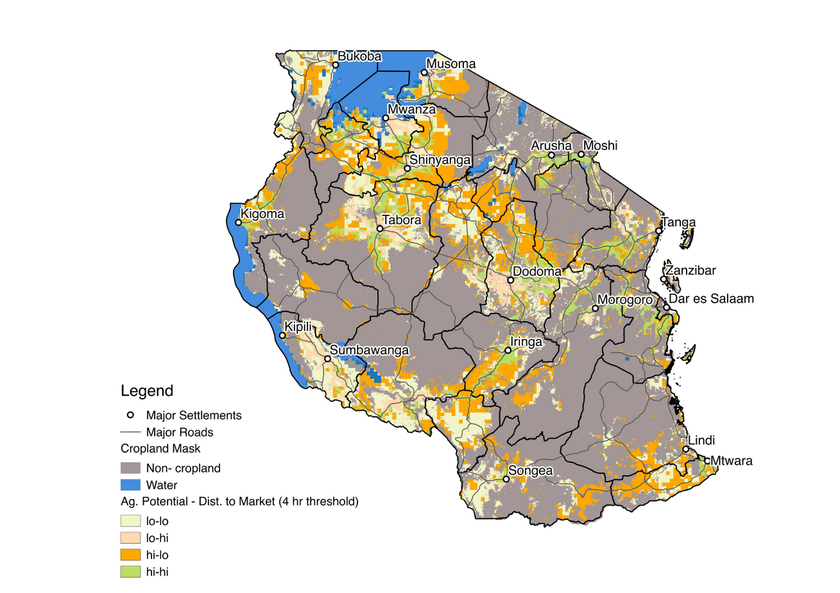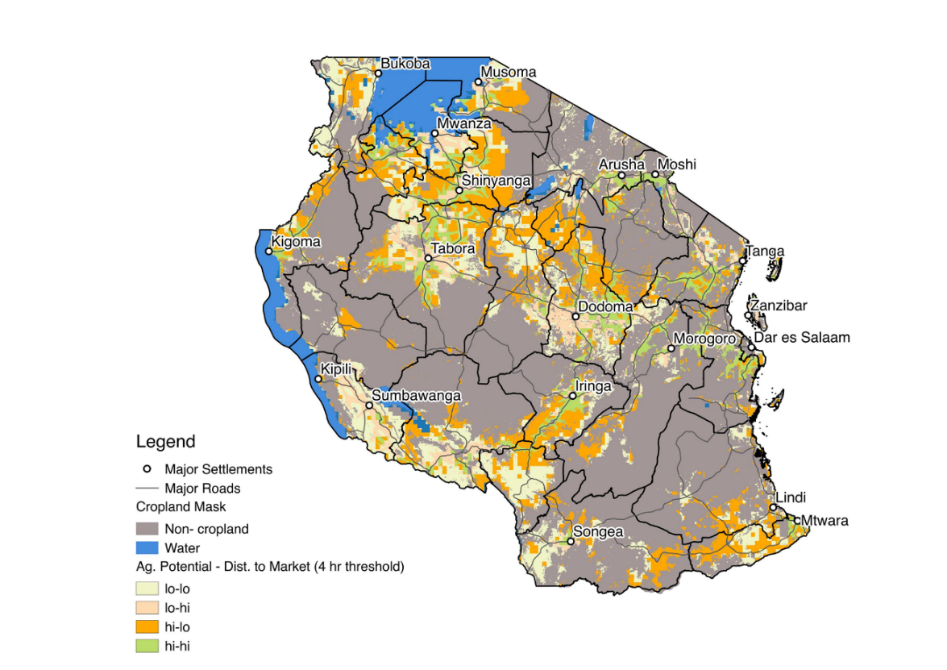

**References**

Carletto, G., Covarrubias, K., Davis, B., Krausova, M., & Winters, P. (2007). Rural Income Generating Activities Study: Methodological note on the construction of income aggregates. Rural Income Generating Activities (RIGA) Project. Food and Agriculture Organization (FAO). Retrieved from <http://www.fao.org/fileadmin/user_upload/riga/pdf/ai197e00.pdf>

Central Statistical Agency of Ethiopia (2017) LSMS-Integrated Surveys on Agriculture, Ethiopia Socioeconomic Survey (ESS), 2015/2016. Retrieved from <http://microdata.worldbank.org/index.php/catalog/2783.>

Ghana Statistical Service (2014) Ghana Living Standards Survey Round 6 (GLSS6) Main Report. Retrieved from <http://www.statsghana.gov.gh/docfiles/glss6/GLSS6_Main%20Report.pdf.>

FAO. (2016). Components of Income Aggregate: Ghana General Living Standards Survey 2012-2013. Rural Income Generating Activities (RIGA) Project. Food and Agriculture Organization (FAO). Retrieved from http://www.fao.org/economic/riga/riga-database/riga-survey/en/

HarvestChoice, International Food Policy Research Institute (IFPRI); University of Minnesota, 2016, "CELL5M: A Multidisciplinary Geospatial Database for Africa South of the Sahara", doi:10.7910/DVN/G4TBLF, Harvard Dataverse, V3

HarvestChoice; International Food Policy Research Institute (IFPRI), 2016, "Travel Time to Markets in Africa South of the Sahara", doi:10.7910/DVN/YKDWJD, Harvard Dataverse, V2.

Hengl, T. (2017) WorldGrids Croplands based on the MOD12Q1 product 2001-2011.

<http://worldgrids.org/doku.php/wiki:l12igb3>

National Bureau of Statistics (2014) Tanzania National Panel Survey Wave 3, 2012-2013. Ministry of Finance, Retrieved from [http://microdata.worldbank.org/index.php/catalog/2252](http://microdata.worldbank.org/index.php/catalog/2252.)

Van Velthuizen, H. (2007) Mapping Biophysical Factors that Influence Agricultural Production and Rural Vulnerability (No. 11). Food & Agriculture Org. <https://books.google.com/books?id=62JdCQJ7ZyQC>

1. While it is likely that the oil and mineral sectors will provide an important, if volatile, source of GDP growth in some African countries, these sectors are not likely to create much additional employment themselves, though they do knock on effects on the demand for services UNCLEAR, IS SOMETHING MISSING HERE?.
2. You et al. (2011) estimate that sub-Saharan Africa could profitably increase its irrigated crop area from surface and groundwater supplies from 7 to 21 million ha by 2050.
3. Estimates vary widely. FAO (2009) estimates that Africa still has a further 800 million ha of uncultivated land with potential for rainfed crop production, whereas Fischer, van Velthuizen,Shah and Nachtergaele (2002) estimate 240 million ha. However, much of this land is used for grazing, is needed for environmental purposes, or is fallow land within extensive farming systems, so cannot easily be used for additional cropping (Conway, 2012, pp. 14–16).
4. Many estimates of past rates of agricultural growth seem too high, capturing the impact of real price increases and production increases. For example, Nin-Pratt, Johnson and Yu (2012) estimate that African agriculture grew by only 3.6% per year in constant prices during 2001–2010, but by 7.7% per year if the deflated increase in agricultural prices is included.
5. Some experts attribute this growth to the spread of improved seeds, thanks in part to the growing role of small and medium-sized seed companies. Others look to a more complex set of factors, including prices, seeds, fertilizer use (and subsidies), mechanization, improved roads, etc.
6. Some research has shown that these kinds of interventions can be effective at the early stages of agrarian development when value chains are still poorly developed, and the demand for key inputs like improved seeds and fertilizers is still too low and spatially thin for private delivery systems to work adequately (Dorward, Kydd, Morrison, & Poulton, 2005, Dorward, Kydd, Poulton, & Bezemer, 2009). But as value chains develop, they become less relevant.
7. Ethiopia and Tanzania surveys are national instances of the World Bank-supported Living Standards Measurement Study—Integrated Survey on Agriculture (LSMS-ISA).